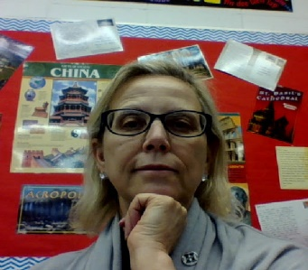Education Closet Summer Conference 2019

*Why I Can’t Do Any Art in My Classroom*

Presenter: Pamela L. Brennan, ELA-Secondary

Hopatcong Middle School

All handouts referenced in the breakout session are housed at the link below and include:

* The 12 Visual Language Alphabet as published in Sunni Brown’s *Doodle Revolution* along with simple worksheet pages to allow students to practice.
* A completed sample Lesson Plan completed in collaboration with two Arts Teachers and the ELA teacher (Defining Human Rights through Struggle).
* A template created by Education Closet to facilitate conversation and collaboration between subject area teachers and Arts teachers for grades K-12.

<https://drive.google.com/drive/folders/1mzI7MNyvhgqS83Tn-8-eAgLT5ymV3Hce?usp=sharing>